1.Git Setup https://confluence.atlassian.com/bitbucket/set-up-git-744723531.html

#sudo apt install -y git

2.Initialize a Git Repository

#git config --global user.name "bhagvatulanipun"
#git config --global user.email "bhagvatula.nipun@tothenew.com"
#Mkdir git_folder
#git init
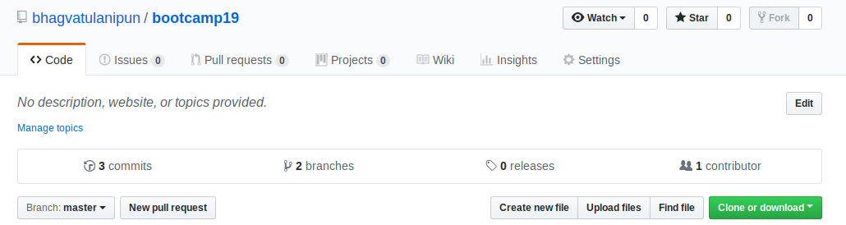

3.Add files to the repository

#git remote add origin git@github.com:bhagvatulanipun/bootcamp19.git
#touch newfile.txt
#git add newfile.txt

4.Unstage 1 file

#git checkout /home/ttn/git_folder/newfile.txt

5.Commit the file

#git commit -m “newfile added”

6.Add a remote

#git remote add origin git@github.com:bhagvatulanipun/bootcamp19.git

7.Undo changes to a particular file

#touch abc
#vim abc
In file:
1
2
3
4
5
#git add abc
#git commit -m “adding abc”
#vim abc
1
2
5
#git commit -m “adding abc again”

Undoing changes
#git reset --hard

8.Push changes to Github

#git push origin master
#vim abc
1
2
3
4
5

9.Clone the repository

Git clone git@github.com:bhagvatulanipun/bootcamp19.git

10.Add changes to one of the copies and pull the changes in the other.
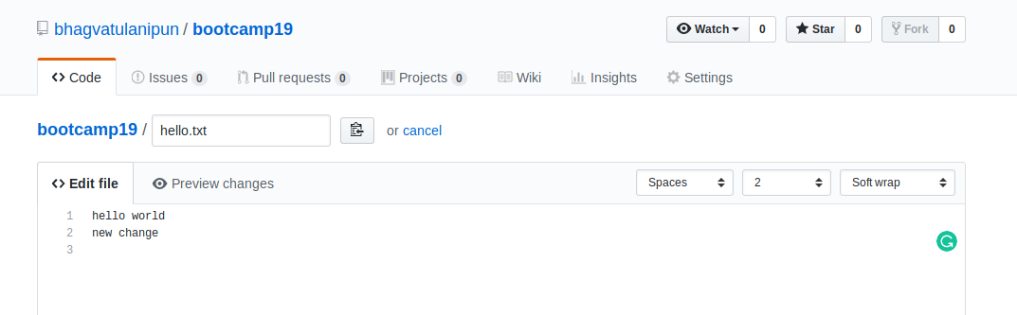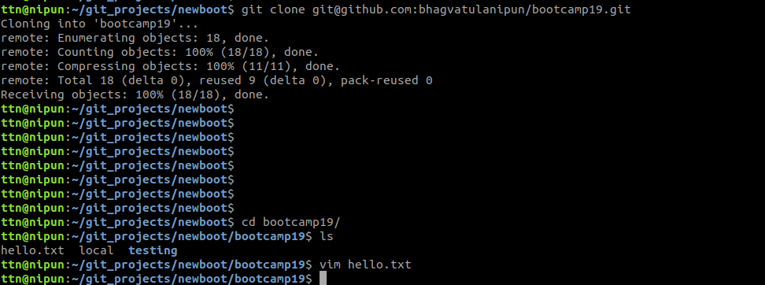

11.Check differences between a file and its staged version

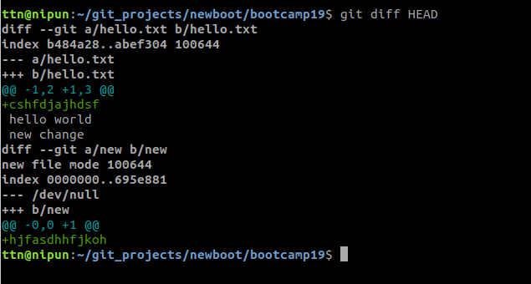
12.Ignore a few files to be checked in

In git local repo

#touch .gitignore
Enter name of the file to be ignored in .gitignore
#git add .gitignore
#git commit -m “ignored file”
#git push origin master

13.Create a new branch.

#git checkout -b nipun

14.Diverge them with commits

Make new file in master abc.txt
#git branch master
#git pull origin master
#git branch nipun
#git merge master
#git add abc.txt
#git commit -m “abc.txt added to nipun”
#git push origin nipun

15.Edit the same file at the same line on both branches and commit
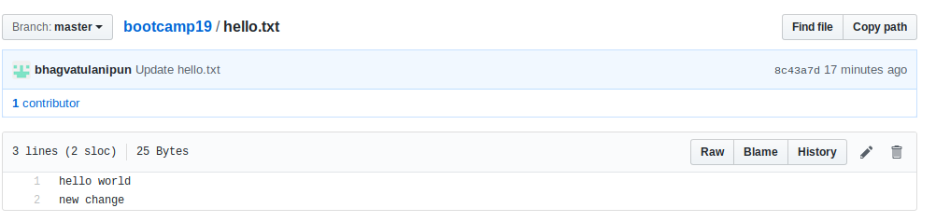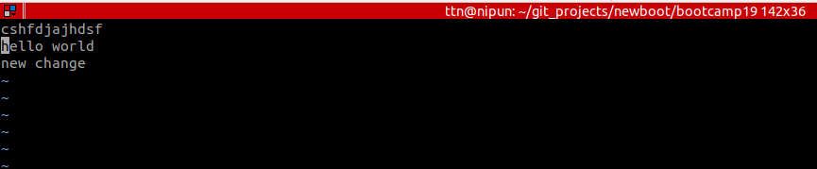

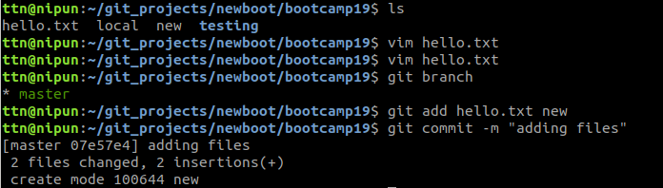

16.Try merging and resolve merge conflicts

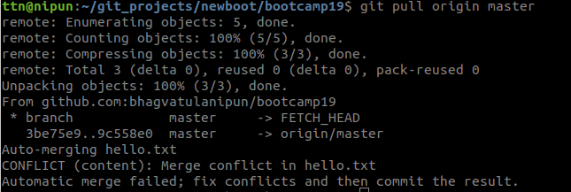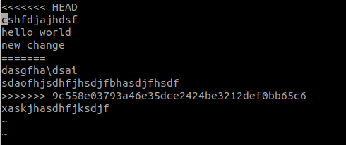

17.Stash the changes and pop them
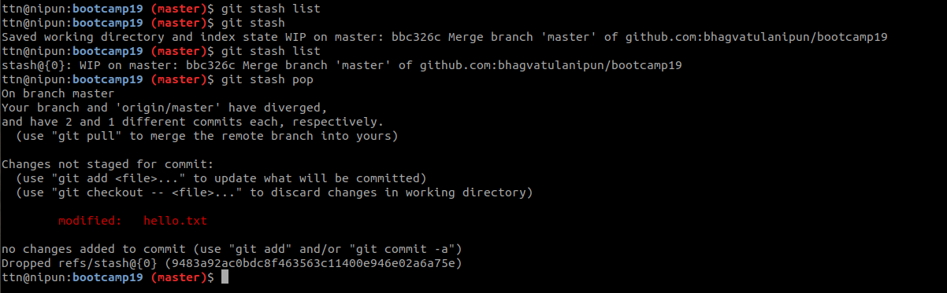

18.Add the following code to your .bashrc file : color_prompt="yes"
parse_git_branch() {
git branch 2> /dev/null | sed -e '/^[^*]/d' -e 's/* \(.*\)/(\1)/'
}
if [ "$color_prompt" = yes ]; then
PS1='\u@\h\[\033[00m\]:\[\033[01;34m\]\W\[\033[01;31m\] $(parse_git_branch)\[\033[00m\]\$ '
else
PS1='\u@\h:\W $(parse_git_branch)\$ '
Fi

